# Comparisons of 3-D acoustics models to shallow water experimental data from the Florida Straits

OCE 673 Advanced Acoustic Propagation, University of Rhode Island  
Sean Reilly, April 2012

# Background

Several papers have recently focused on the presence of strong 3-D propagation effects in experimental data on the continental shelf in the Florida Straits area. The South Florida Ocean Measurement Center is a permanent underwater laboratory located on the continental shelf just south of Ft. Lauderdale [1]. The experiments in the area include not only acoustics, but supporting environmental including in-situ CTD ocean profiles, high resolution bathymetry measurements, and core sample of the ocean bottom.

During a 1999 experiment to estimate sediment properties from an acoustic inversion at this site, researchers concluded that their experiment was strongly influenced by secondary signals that originated from horizontal refraction effects [2]. In this experiment, M-sequence coded signals were transmitted with a source level of 198 dB//μPa, and frequencies from 100 to 3200 Hz, over a range of 10 km to a sparsely populated vertical array. Signal propagation was parallel to the coast along the slope at a water depth of 155 m. The sound velocity profile was strongly downwardly refracting. A simulation study based on a 3-D parabolic equation model (3DWAPE) and a 3-D ray model (MOC3D) later concluded that these secondary signals could be directly attributed to horizontal refraction from cross-slope specular reflections inshore of the straight line path between source and receiver [3].

The Calibration Operations (CALOPS) experiment found similar effects in this area in the late summer (September 7–15) of 2007 and in the winter (February 19–25) of 2008 [4]. The CALOPS experiment used a horizontal line array (HLA) of 120 elements, with ½ wavelength spacing at 450 Hz (1.75 m), resting on the bottom, perpendicular to the 250 m isobaths. A towed 171 dB//μPa source used a combination of 60 second long CW pulses, with frequencies of 24, 52.5, 106, 206, and 415 Hz and a 30-s multi-band set of five linear frequency modulated (LFM) pulses in the frequency bands 20–50, 50–100, 120–180, 200–300, and 320–420 Hz. The ship followed tracks parallel to the 120, 250, and 450 m isobaths out to a range of 80 km. The source was also towed up-shelf from deep to shallow water at range of approximately 30 km from the source.

The CALOPS experiment recorded acoustic paths that were as much as 30 degrees away from the true bearing between source and receiver. In many cases, the in-shore refracted path was as much as 20 dB stronger than the true bearing path. Subsequent modeling studies also concluded that the out-of-plane paths were the result of horizontal refraction cause by multiple specular reflections from the sloped bottom [5] [6]. Both of these studies used an adiabatic mode parabolic equation (AMPE) to compare the transmission loss, angle of arrival, and time of arrival to Summer 2007 experimental results along the 250 m isobath, with a source depth of 100 m (Run 1N). The Heaney et. al. study [5] focused on the CW results at 206 and 415 Hz, where the signal to noise was the greatest. The Ballard study [6] focused on the CW results at 52.5 Hz, where bottom penetration plays a larger role.

In this study, the CALOPS experimental results that were previously studied by Heaney, Ballard, et. al. will be used to test the accuracy of the Wavefront Queue 3-D (WaveQ3D) model [7]. The WaveQ3D model implements Hybrid Gaussian beams [8]in a fully 3-D ocean environment that is based on latitude, longitude, and altitude. The approach is designed to provide a significant speed advantage to real-time, active sonar, simulation/stimulation systems in littoral environments. The expectation is that WaveQ3D model will provide accurate transmission loss values above 150 Hz. But at lower frequencies, we expect the effects of unsupported bottom penetration to cause deviations from the experimental data. In subsequent studies, we hope to expand this analysis to all of the Run 1N CW frequencies and to the VLA receivers from the 1999 experiment.

# Environment Characterization

The bathymetry for this analysis was modeled using the U.S. Coastal Relief Model (CRM) [9]. This database provides gridded bathymetry, at 3 arc-second resolution, for the U.S. East and West Coasts, the northern coast of the Gulf of Mexico, Puerto Rico, and Hawaii, reaching out to the continental slope. Custom grids are freely available through the Geophysical Data System (GEODAS) Search and Data Retrieval web site [10]. In a follow-on effort, we hope to get access to higher resolution collected by the 2007 CALOPS experiment.

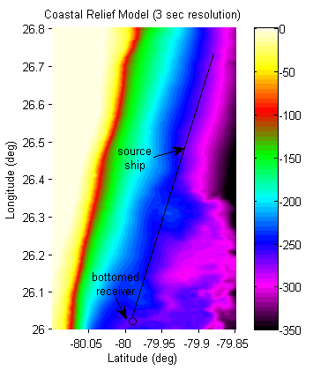

Figure 1 – Bathymetry and ship track

The geophysical properties of the bottom (Table 1) were modeled using Ballard’s analysis of measurements around this site [6]. Below the 236 m isobaths, the bottom is bare limestone because loose sediments have been scoured off by the Florida current. At shallower depths, the bottom is carbonate sands. The large shear speeds of the limestone results in higher bottom loss, compared to the sand, at grazing angles below 20 degrees. Ballard also demonstrates that including shear speeds as high as 200 m/s have little effect on the low angle bottom loss in the carbonate sands. This effort does not include the pools of sand over the limestone discussed by Ballard, but we hope to address those phenomena in a follow-on effort.

Table 1 – Geophysical Bottom Properties

|  |  |  |
| --- | --- | --- |
| Property | Limestone | Sand |
| Compression wave speed (m/s) | 3000 | 1676 |
| Compression attenuation (dB/k) | 0.10 | 0.01 |
| Shear wave speed (m/s) | 1430 | 0 |
| Shear attenuation (dB/k) | 0.20 | 0 |
| Density (g/cm3) | 2.40 | 1.70 |



Figure 2 – Bottom loss model for limestone and sand bottoms

The refractive properties of the ocean (Table 1) were modeled using Heaney’s analysis of measurements around this site [4]. This analysis suggests that a single sound velocity profile (Figure 3) can be used as an initial estimate of the ocean conditions in the whole area. For this analysis, a piecewise cubic Hermite interpolating polynomial (PCHIP) will be used to create a continuous profile from this data. Unfortuately, the profiles from Heaney’s analysis only go down to 250 m; but, this is the only portion critical for up-slope analysis. Using Ballard’s analysis [6], we assume that the profiles are approximately isovelocity below 250 m. In a follow-up effort, we plan to create a 3-sound velocity profile that includes all of CTD in-situ measurements discussed in Ballard’s work.

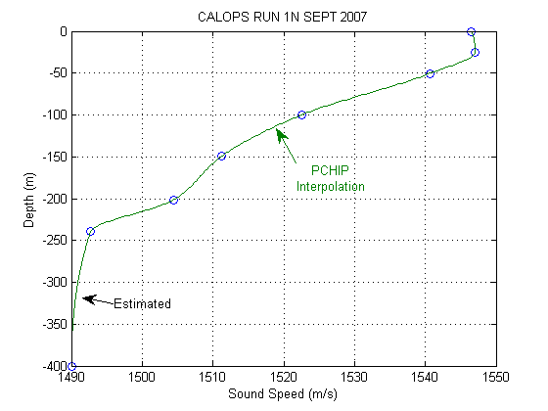

Figure 3 – Sound speed profile for CALOPS Run 1N September 2007

# Results

# Conclusions

In a follow-on effort, we hope to extend this analysis and seek publication of these results. However, we recognize that several improvements will be required in the environment characterization:

* Include the higher resolution collected by the 2007 CALOPS experiment,
* Model discreet pools of sand over the limestone (discussed by Ballard [6]),
* Use all of the in-situ CTD measurements instead of a single profile.
* Extend the analysis to include Jianga’s VLA measurements [2] in the water column.

# Bibliography

|  |  |
| --- | --- |
| [1] | H. B. Nguyen, H. A. DeFerrari, N. J. Williams and W. A. Venezia, "Ocean Acoustic Sensor Installation at the South Florida Ocean Measurement Center," *IEEE J. Ocean. Eng.,* vol. 27, no. 2, pp. 235-244, April 2002. |
| [2] | Y. Jiang, N. R. Chapman and H. A. DeFerrari, "Geoacoustic inversion of broadband data by matched beam processing," *J. Acoust. Soc. Am.,* vol. 6, no. 119, pp. 3707-3706, June 2006. |
| [3] | F. Sturm, S. Ivansson, Y. M. Jiang and N. R. Chapman, "Numerical investigation of out-of-plane sound propagation in a shallow water experiment," *J. Acoust. Soc. Am.,* vol. 6, no. 124, December 2008. |
| [4] | K. D. Heaney and J. J. Murray, "Measurements of three-dimensional propagation in a continental shelf environment," *J. Acoust. Soc. Am.,* vol. 3, no. 125, pp. 1394-1402, March 2009. |
| [5] | K. D. Heaney, R. L. Campbell and J. J. Murray, "Comparison of hybrid three-dimensional modeling with measurements on the continental shelf," *J. Acoust. Soc. Am.,* vol. 2, no. 131, pp. 1680-1688, February 2012. |
| [6] | M. S. Ballard, "Modeling three-dimensional propagation in a continental shelf environment," *J. Acoust. Soc. Am.,* vol. 3, no. 131, pp. 1969-1977, March 2012. |
| [7] | G. P. M. G. Sean M. Reilly, "Sonar Propagation Modeling using Hybrid Gaussian Beams in Spherical/Time Coordinates," Department of Ocean Engineering, University of Rhode Island, January 2012. |
| [8] | H. Weinberg and R. E. Keenan, "Gaussian ray bundles for modeling high-frequency propagation loss under shallow-water conditions," *J. Acoust. Soc. Amer.,* no. 100, p. 1421, 1996. |
| [9] | NOAA National Geophysical Data Center (NGDC), "U.S. Coastal Relief Model," [Online]. Available: http://www.ngdc.noaa.gov/mgg/coastal/crm.html. [Accessed April 2012]. |
| [10] | NOAA National Geophysical Data Center (NGDC), "GEODAS (GEOphysical DAta System)," [Online]. Available: http://www.ngdc.noaa.gov/mgg/geodas/geodas.html. [Accessed 4 2012]. |